“Київський фаховий коледж зв’язку”

Циклова комісія Комп’ютерної інженерії

**ЗВІТ ПО ВИКОНАННЮ**

**WORK-CASE №3**

з дисципліни: «Операційні системи»

Виконавли студенти

групи РПЗ-03

Команда: Губенко Є.О.,

Заїка С.В. та Кресан Р.А.

Перевірив викладач

Сушанова В.С.

Київ 2022

**Хід роботи**

***Готував матеріал студент: Кресан Р.А.***

1. **В робочому середовищі віртуальної машини Virtual Box, VMWare Workstation (або інший на Ваш вибір) необхідно виконати:**

* **Cloning your virtual desktop (Work-case 2). How can this be done? Let's demonstrate all the steps;**

*To clone a virtual OS, you need to select the virtual machine you want to clone, press the “Menu” button and select the Snapshots item from the list.*

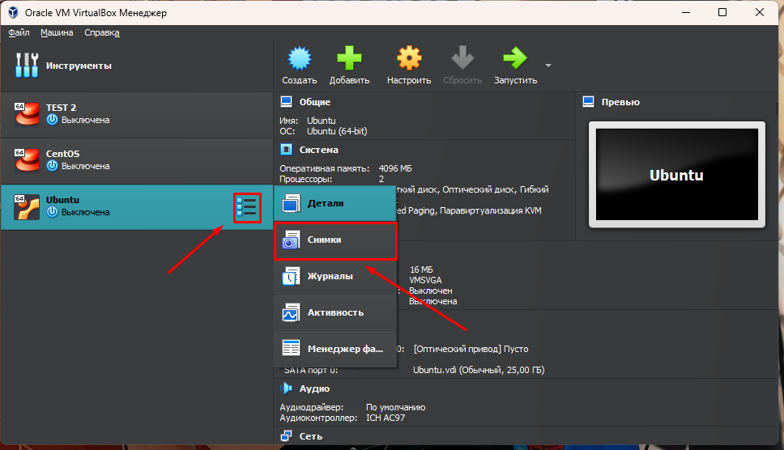

*In the menu that opens, click the “Clone” button.*

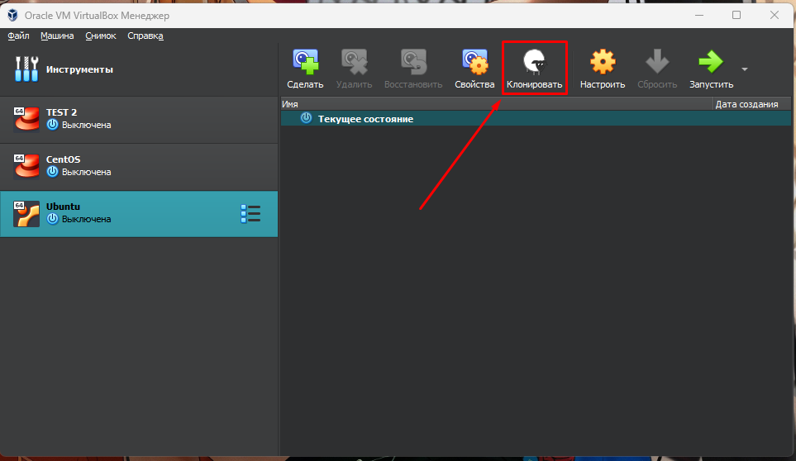

*The virtual machine cloning settings window opens. In this window, enter the name of the new virtual machine and specify the path where it will be located.*

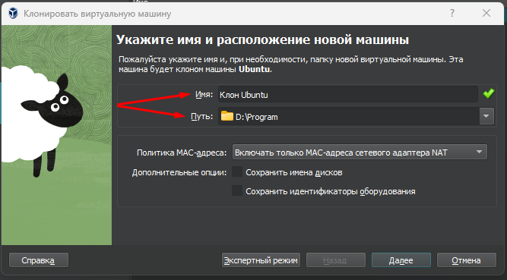

*Next, you need to specify the type of cloning and click the “Done” button.*

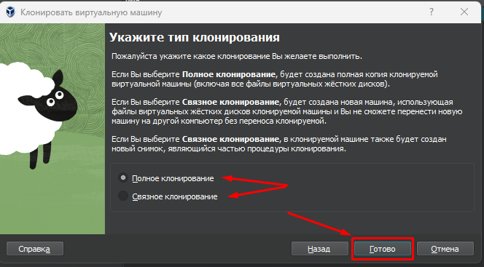

*After that, the cloning process will begin*

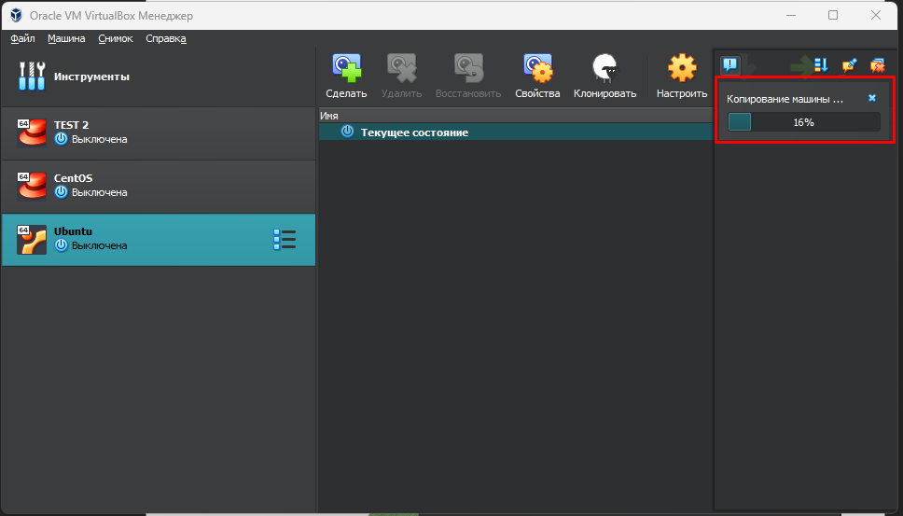

*When the cloning process is over, our cloned system will appear in the list of available virtual machines.*

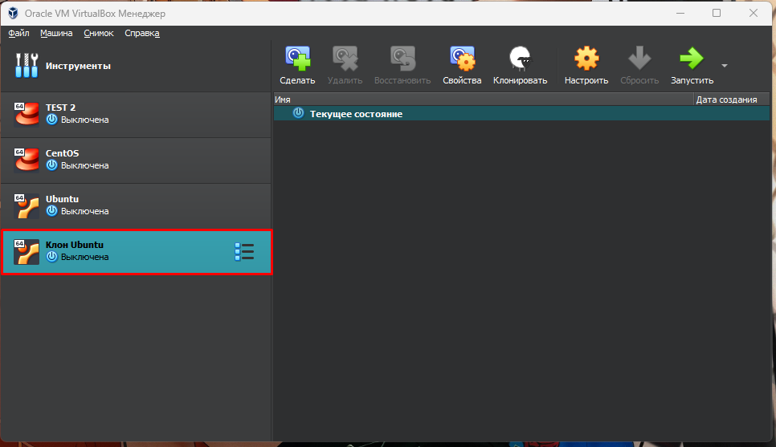

* **You may need to move (clone) the OS to another virtual environment. What steps to take to export your virtual desktop OS?**

*To export the virtual machine configuration, click the "File" button and select the "Export Configuration" item in the drop-down list, or press the CTRL+E key combination.*

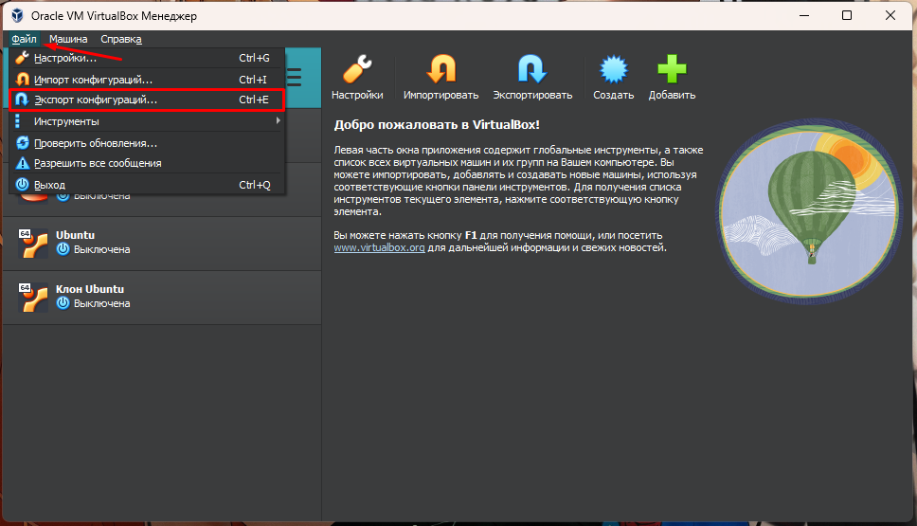

*The configuration export window appears, in which you need to select a virtual machine and click “Next up”.*

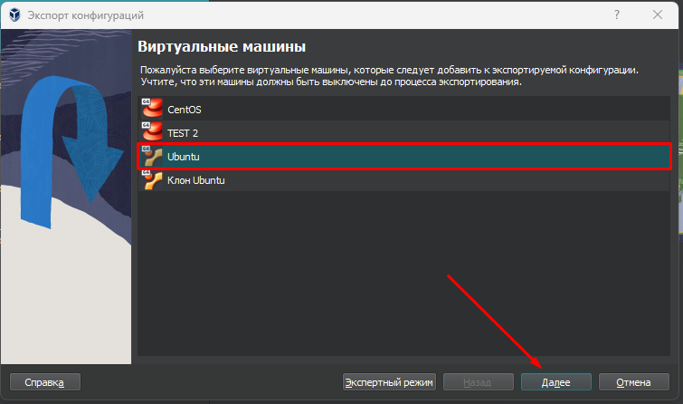

*Next, you need to specify the name and path for the export and click the “Next up” button.*

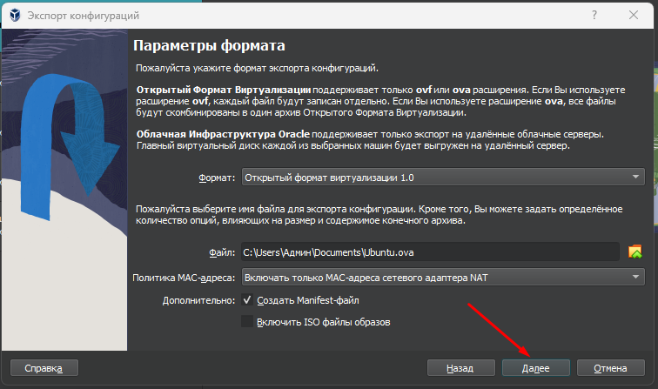

*Then the export settings window will appear where we can view the configuration description. If necessary, we can change them by double-clicking the mouse button.*

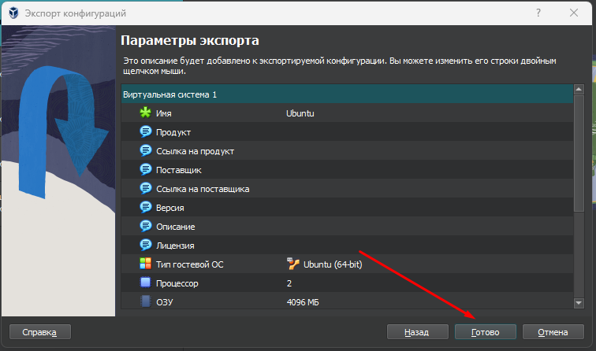

*After clicking the "Finish" button, the system configuration recording will begin.*

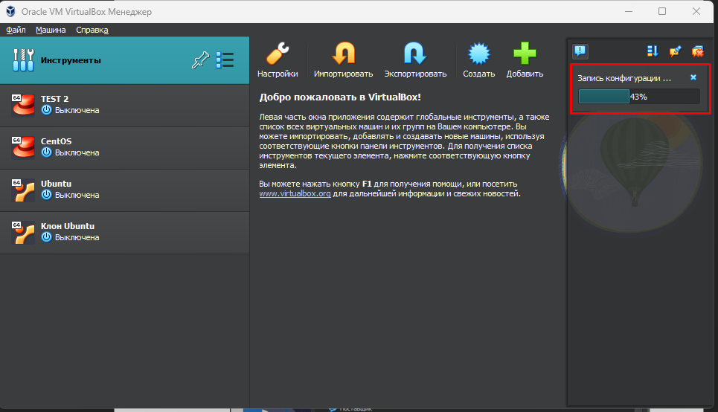

*At the end of the recording, the virtual machine configuration file will appear in the path we specified.*

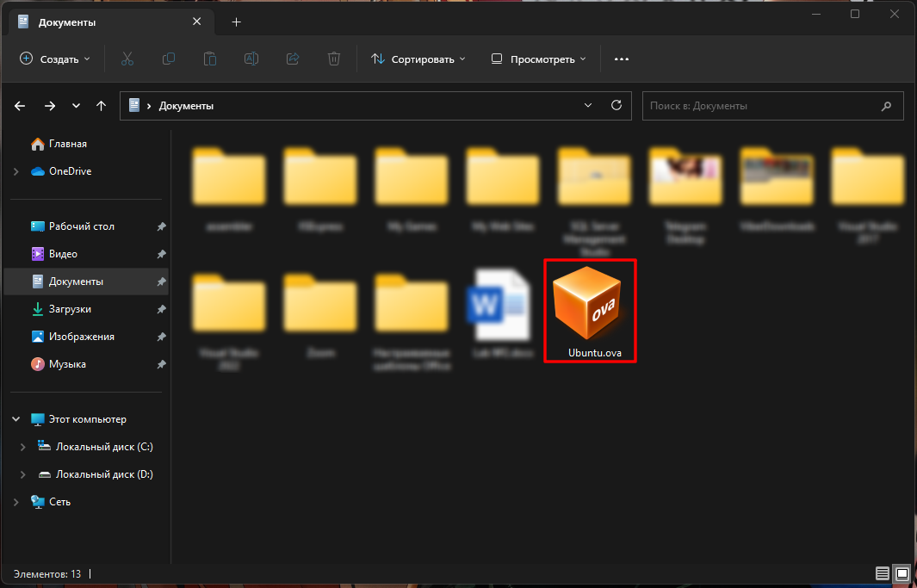

***Готував матеріал студент: Губенко Є.О.***

1. **В ході роботи одна робоча віртуальна машина може взаємодіяти з іншою. Для цього необхідно між ними розгорнути мережу. Опишіть які типи організації мережевих з’єднань підтримуються в середовищі віртуальних машин, в чому особливість кожного з них:**

* **Трансляція мережевих адрес (NAT);**

*In this mode, the virtual machine is connected to the network through a virtual network adapter, but access to the outside world is provided through a NAT router that is created within the host system. The peculiarity of this type of connection is that all packets sent from the virtual machine to the outside world are passed through a NAT router that broadcasts their network addresses, which allows you to use a limited number of public IP addresses.*

* **Мережевий міст (Bridged);**

*In this mode, the virtual machine is connected to a real network, which allows it to interact with other devices on that network like other physical devices. A feature of this type of connection is that the virtual machine gets its own IP address on the network.*

* **Віртуальний адаптер хоста (Host-only);**

*In this mode, the virtual machine is connected to the host system (that is, the computer on which it is running) through a virtual network adapter. The virtual machine cannot interact with the outside world, but it can communicate with the host system and other virtual machines on the same network*

* **Внутрішня мережа (Internal Network).**

*A type of network connection that is available in a virtual machine environment. This type of network has no connection to the outside world and no access to the Internet. An internal network is created to connect virtual machines that run within the same physical server.*

*In an internal network, each virtual machine gets its own IP address within this network. All virtual machines within the internal network can communicate with each other, but cannot connect to an external network. Thus, this type of network provides interaction between virtual machines that are used in the same system, but ensures their isolation from the outside world.*

*An internal network is useful when you need to run multiple virtual machines for testing, development, or training and want them to interact with each other but be isolated from the outside world. In addition, this type of network can be useful for creating a separate internal network for certain applications or services that do not require a connection to the Internet or an external network.*

***Готував матеріал студент: Кресан Р.А.***

1. **Розгорніть мережу між вашою робочою ОС та її клоном (завдання 1):**

* **Продемонструйте базові команди для налаштування мережевих параметрів ОС, поясніть, що вони виконують.**

*The main commands for configuring OS network settings depend on the operating system, but in general, they can be divided into several categories:*

1. *Commands to view network settings:*

* *ifconfig: Displays the current settings of the network interfaces, such as IP address, netmask, MAC address, etc.*
* *ip addr show: Displays detailed information about network interfaces, including type, MAC address, IP address, netmask, and other parameters.*

1. *Commands to change network settings:*

* *ifconfig <interface> <IP address> netmask <netmask>: Sets a new IP address and netmask for the network interface.*
* *ip addr add <IP_address>/<netmask> dev <interface>: Adds a new IP address to the network interface.*
* *route add default gw <gateway_IP>: Sets the default gateway IP address for the NIC.*

1. *Commands to restart the network:*

* *service networking restart: Restarts networking services on Ubuntu/Debian.*
* *systemctl restart network: restarts network services on CentOS/RHEL.*
* *ifdown <interface> && ifup <interface>: disables and enables a network interface.*

1. *Commands for network diagnostics:*

* *ping <IP address>: Checks the availability of a network device using ICMP packets.*
* *traceroute <IP address>: Displays the route that packets take to reach the network device.*
* *netstat -rn: Displays the routing of network packets for the current network.*
* **‘Обидві ОС мають мати вихід у мережу Інтернет. Відкрийте браузер та перегляньте будь-яке відео в youtube.**

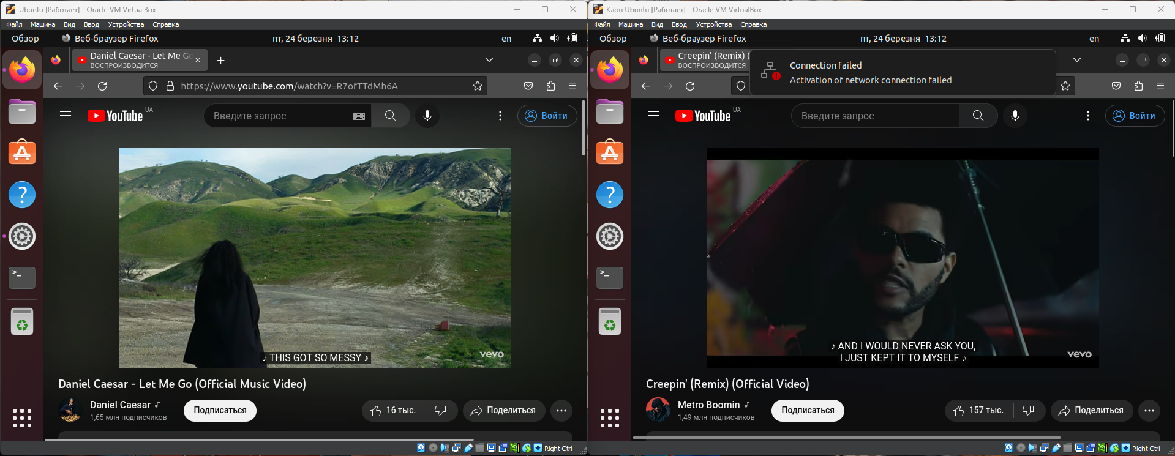

* **Налаштуйте та продемонструйте обмін повідомленнями між двома ОС по локальній мережі. Які команди в терміналі при цьому необхідно ввести?**

*To exchange messages, you need to find out the IP address of each virtual machine. First, on the second virtual machine, we find out the IP address, then start listening on port 1111. After that, on the host machine, you need to write a message, the IP address of the second virtual machine and the port we entered earlier.*

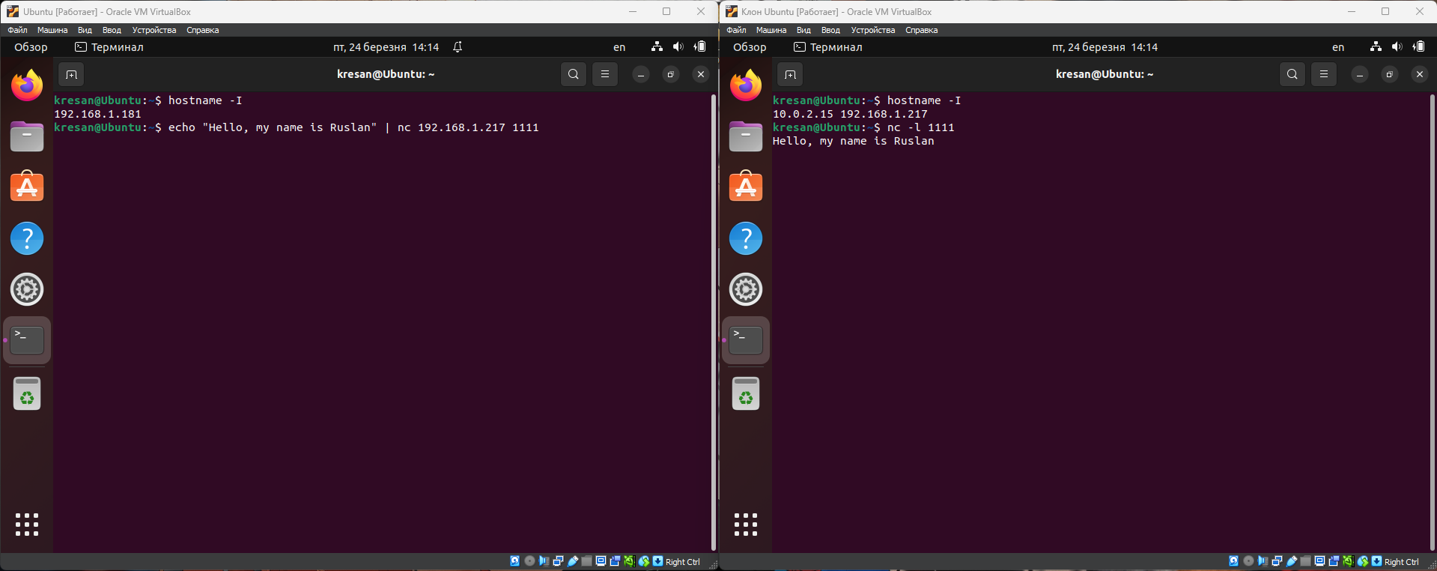

* **Налаштуйте спільну мережеву папку для обох ОС. Спробуйте скопіювати файли з цієї директорії в домашній каталог користувача (віртуальна робоча ОС) та на робочій стіл (клон віртуальної робочої ОС).**

*To set up a network folder on two OSes, you need to download and configure "nautilus-share" and "system-samba-config" on both virtual machines. Once configured, we create a folder called "WC3" (WORK-CASE 3) and add the audio file to it.*

|  |  |
| --- | --- |
|  |  |

*After that, click on the folder with the right mouse button and select “sharing options”.*

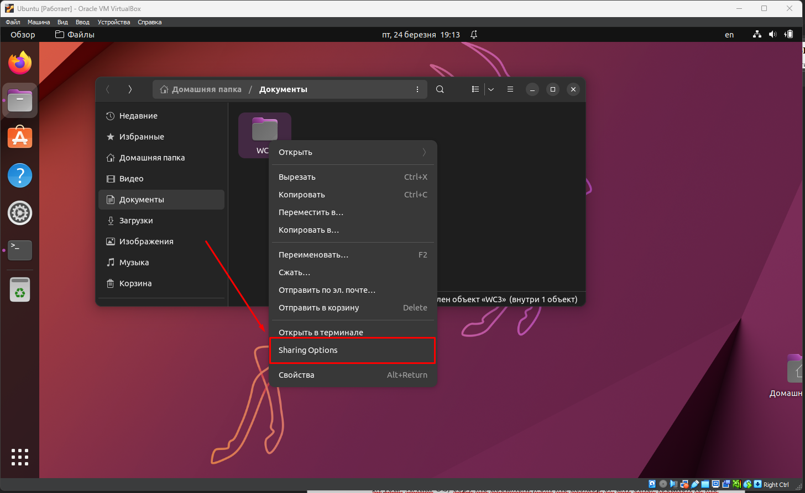

*A window opens in which you need to click the checkbox "Open folder sharing" and click the accept button.*

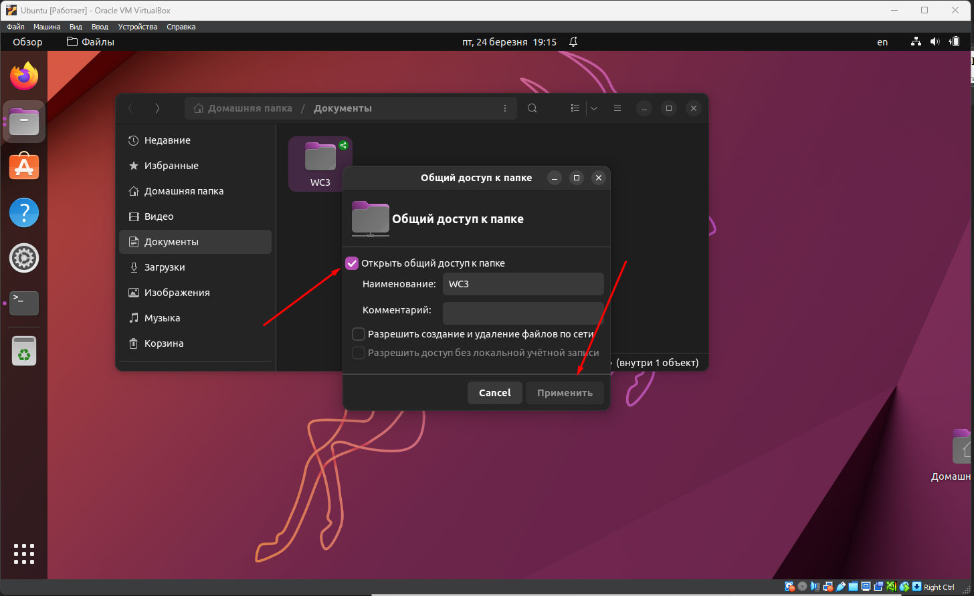

*On the second virtual machine, select the “Other locations” item.*

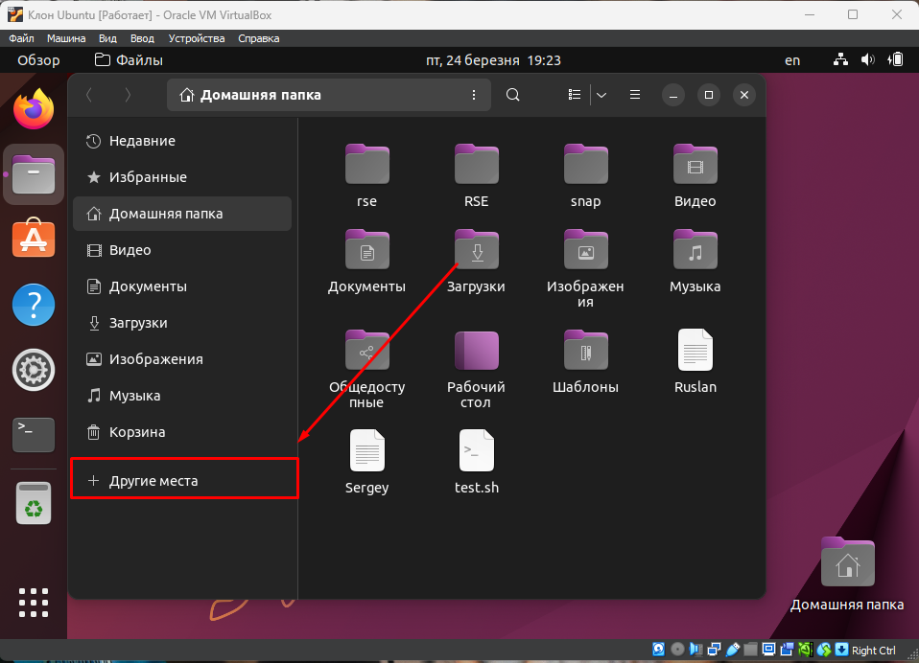

*Select another virtual machine on the network.*

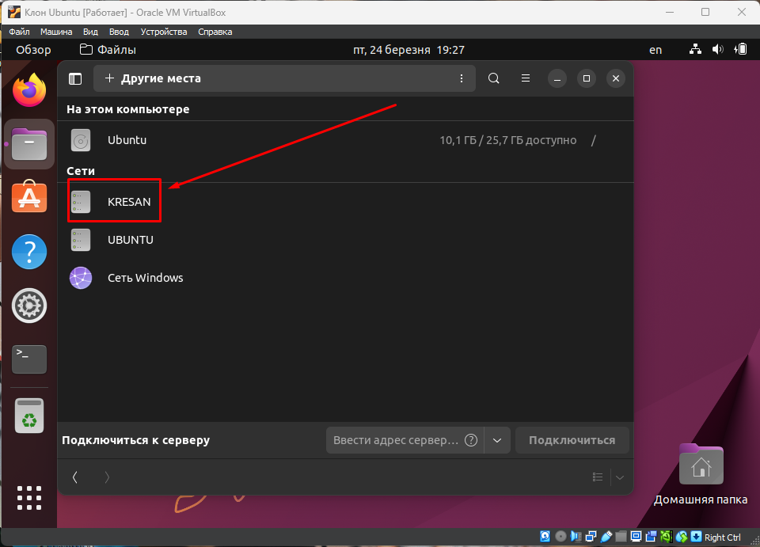

*Our file will appear here, which we can open*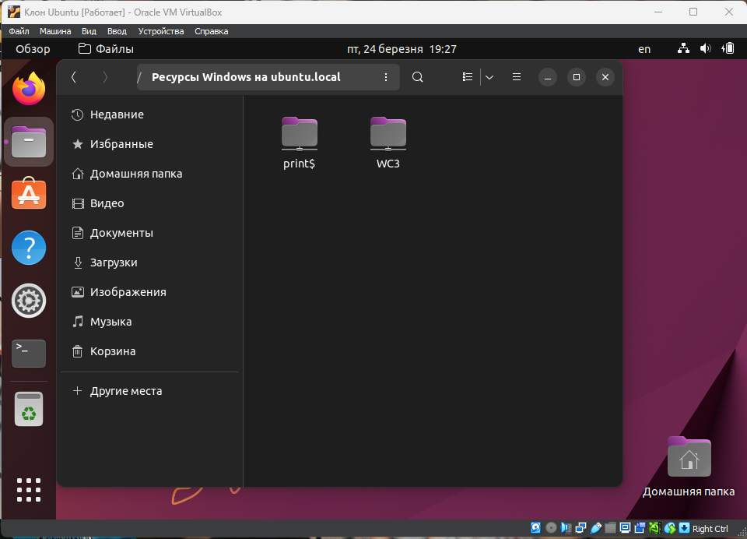

*The system requires authentication to open. It will offer to connect anonymously and log in as a registered user.*

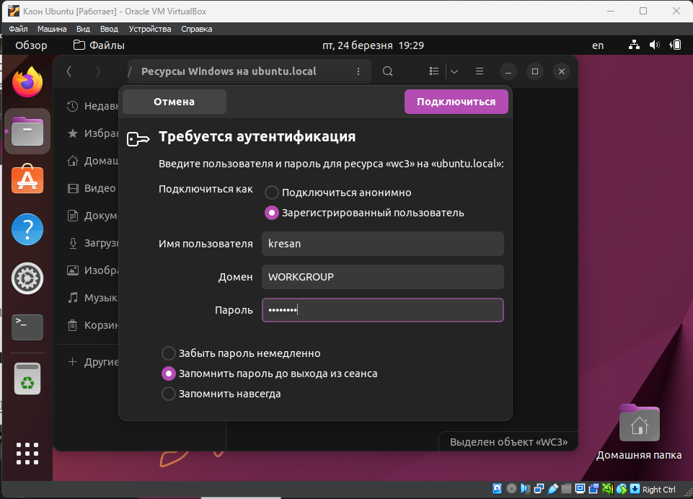

*After we have entered the password, we can view what is in this folder, in our case it is an audio file that we added there in the main virtual machine.*

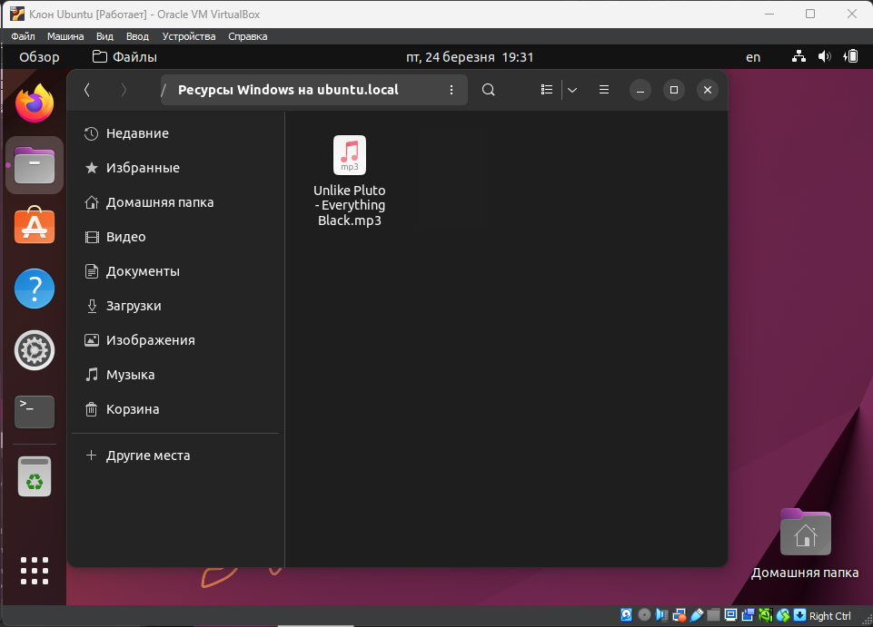

***Готував матеріал студент: Заїка С.В.***

1. **Яким чином можна організувати обмін інформацією між вашою основною ОС (наприклад Windows) та віртуальними ОС? Скопіюйте довільний аудіо- файл з вашої основної ОС на робочий стіл віртуальної ОС та її клона. Як зробити зворотну дію, коли треба документ з робочого столу віртуальної ОС скопіювати до вашої основної робочої ОС?**

*To organize the exchange of information between the main and virtual operating systems, you can use shared folders or shared disks, which are available for both the main and virtual operating systems. This allows you to transfer files between the two operating systems. To copy an arbitrary audio file from the primary OS to the desktop of the virtual OS and its clone, do the following:*

* *Open the virtualization program and start the virtual OS.*
* *In the virtual OS, find the shared folder or shared drive you want to use to transfer the audio file.*
* *Copy the audio file from your main OS and paste it into the shared folder or shared drive you found in step 2.*
* *In your virtual OS, navigate to the shared folder or shared drive and copy the audio file to your desktop or any other location you want.*
* *If you cloned a virtual OS, repeat the same steps on the cloned OS*

*To copy a document from the virtual OS desktop to your main operating system, do the following:*

* *Find the shared folder or shared drive that you want to use to move the document from the virtual OS to the main OS.*
* *In the virtual OS, copy the document from the desktop or any other location to the shared folder or shared drive.*
* *Open the main OS and navigate to the shared folder or shared drive you used in step 2.*
* *Copy the document from the shared folder or shared drive and paste it to the desired location on your main OS.*